DHA Suffa University

Department of Computer Science


DIALOGIX (TRANSFORMING DATA ANALYTICS USING AI)

Final Year Project Report

Submitted by
Sonu Kotak se211081 Tayyaba Faisal se211096
Mahwish Fatima Jafri se211103

Supervisor
Ms. Sumera Rounaq
In partial fulfilment of the requirements for the degree of Bachelor of Science in Computer Science
2025

Certificate of Approval
It is certified that the work presented in this report, entitled <project title> was conducted by Sonu kotak ,Tayyaba faisal, and Mahwish Fatima under the supervision of Ms.Sumera Rounaq
No part of this report has been submitted anywhere else for any other degree.

This report is submitted to the Department of Computer Science in partial fulfilment of the requirements for the degree of Bachelor of Science in Computer Science

at DHA Suffa University (DSU)

Team Lead Name: Sonu kotak Signature:

Member 1 Name: Tayyaba Faisal Signature:

Member 2 Name: Mahwish Fatima Jafri Signature:
Supervisor Name: Ms. Sumera Rounaq Signature: 

Authors’ Declaration
We declare that this project report was carried out in accordance with the rules and regulations of the DHA Suffa University (DSU). The work is original except where indicated by special references in the text and no part of the report has been submitted for any other degree. The report has not been presented to any other University for examination.

Dated: 07/20/2025 Authors Signatures:

Sonu Kotak

Tayyaba Faisal

Mahwish Fatima Jafri

Plagiarism Undertaking
We, Sonu Kotak, Tayyaba Faisal, and Mahwish Fatima Jafri solemnly declare that the work presented in the Final Year Project Report titled DIALOGIX (TRANSFORMING DATA ANALYTICS USING AI) has been carried out solely by ourselves with no significant help from any other person except few of those which are duly acknowledged. I confirm that no portion of our report has been plagiarized and any material used in the report from other sources is properly referenced.

Dated:

Authors Signatures:

Sonu Kotak

Tayyaba Faisal

Mahwish Fatima Jafri

Acknowledgments

Document Information

Category | Information
Customer | DHA Suffa University (DSU)
Project Title | DIALOGIX (TRANSFORMING DATA ANALYTICS  USING AI)
Document | Final Year Project Report
Document Version | 1.0
Identifier | P34F24 Final Report
Status | Final
Author(s) | Tayyaba Faisal Mahwish Fatima Jafri  Sonu Kotak
Approver(s) | Ms. Sumera Rounaq
Issue Date

Definition of Terms, Acronyms, and Abbreviations

Term | Description
Business  Intelligence | Technology-driven processes for analyzing data and offering useful insights help business leaders make better decisions. This usually involves collecting and examining data, creating reports, and evaluating performance to guide decision-making.
Natural  Language Querying | Users can easily ask questions about their data using everyday language, like "What were last month's sales?" The AI understands the question, analyzes the data, and provides useful insights or visualizations in response.
Anomaly Detection | Anomalies are data points that stand out because they are very different from most of the other data. These unusual patterns could signal possible fraud, problems in operations, or unexpected trends in business.

Machine Learning Algorithms | Machine learning is a type of AI where computers are taught to recognize patterns in data. They use algorithms like linear regression, decision trees, and neural networks to make predictions or classify information. These tools help solve problems such as forecasting future trends or sorting items into categories.
Predictive Analytics | Techniques that use historical data to make predictions about future outcomes. It often involves the use of machine learning models to forecast trends, such as sales, customer behavior, or financial performance.
Anomaly Detection | The identification of rare or unusual data points that deviate significantly from the majority of the data. Anomalies can represent potential fraud, operational issues, or unexpected trends in business data.

Abstract
DialogixAI is an AI-powered data analytics application designed for accessible, user-friendly data analysis without requiring technical expertise. Users can import data from various sources, which the AI automatically cleans, preprocesses, and analyzes. The app supports natural language querying, predictive analytics, and customizable reports, along with polished visualizations and interactive dashboards for clear insights. Collaboration features allow sharing insights directly with team members, while security protocols ensure data safety. With voice-activated results, mobile optimization, and intuitive guidance, DialogixAI aims to simplify data analysis for all users, making it a powerful tool for modern business insights and decision-making.

Workflow:

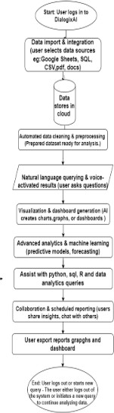

Table of Contents

Certificate of Approval 2
Authors’ Declaration 3
Acknowledgment 5
Document Information 6
Abstract 7
Chapter 1 INTRODUCTION 10
Description about Project 10
Details about the Domain 10
Relevant Background 10
Chapter 2 RELEVANT BACKGROUND & DEFINITIONS 11
Chapter 3 LITERATURE REVIEW & RELATED WORK 12
Literature Review 12
Related Work 12
Gap Analysis 12
Chapter 4 METHODOLOGY 13
Software Engineering Methodology 13
Project Methodology 14
Chapter 5 EXPERIMENTAL EVALUATIONS & RESULTS 15
Evaluation Testbed 15
Results and Discussion 15
Chapter 6 CONCLUSION AND DISCUSSION 16
Limitations and Future Work 16
Reasons for Failure – If Any 16
REFERENCES 17
APPENDICES 18
A0. Copy of Project Registration Form 19
A1a. Project Proposal and Vision Document 20
A1b. Copy of Proposal Evaluation Comments by Jury 21
A2. Requirement Specifications 22
A3. Design Specifications 23
A4. Other Technical Detail Documents 24
Test Cases Document 24
UI/UX Detail Document 24
Coding Standards Document 24
Project Policy Document 24
User Manua1 Document 24
A5. Flyer & Poster Design 25
A6. Copy of Evaluation Comments 26
Copy of Evaluation Comments by Supervisor for Project – I Mid Semester Evaluation 26
Copy of Evaluation Comments by Supervisor for Project – I End Semester Evaluation 27
Copy of Evaluation Comments by Jury for Project – I End Semester Evaluation 28
Copy of Evaluation Comments by Supervisor for Project – II Mid Semester Evaluation 29
Copy of Evaluation Comments by Jury for Project – II End Semester Evaluation 31
A7. Meetings’ Minutes 32
A8. Document Change Record 33
A9. Project Progress 34
A10. Research Paper 35

CHAPTER 1
INTRODUCTION

Description of the Project
DialogixAI is an AI-driven data analytics web application designed to simplify how users interact with datasets and extract insights. The system enables users to upload structured data (such as CSV files), visualize it through interactive charts and tables, and receive intelligent summaries and insights through an integrated AI assistant.

Built using React, TypeScript, and Vite, DialogixAI focuses on providing a clean, responsive, and intuitive frontend experience for business users, students, and analysts who may not have advanced technical backgrounds. The project aims to bridge the gap between raw data and actionable understanding by integrating natural language assistance and dynamic visual tools.

The current phase of the project emphasizes frontend development, simulating features like: Interactive dashboards with chart and table components
Column filtering and sorting
AI-powered chatbot interface (currently mock-based) User-friendly data upload and exploration experience

Details about the Domain
The project falls under the intersection of the following domains:

Data Analytics
Data analytics refers to the science of analyzing raw data to draw conclusions and discover trends. In businesses and research, analytics helps improve decision-making, optimize performance, and identify opportunities. DialogixAI facilitates this by transforming structured data into visual narratives.

Artificial Intelligence (AI)
AI is employed in the form of a conversational assistant capable of interpreting user queries, summarizing datasets, and guiding users through analytics tasks. While the current system uses mocked AI responses, the structure is designed for integration with large language models (LLMs) to provide real-time natural language understanding.

Human-Computer Interaction (HCI)
The system is designed with a focus on usability and interactivity. Features such as

drag-and-drop data upload, hover tooltips, and dynamic charts make the system user-friendly, especially for non-technical users.

Web Development (Frontend Engineering)
DialogixAI is implemented as a single-page application (SPA) using modern web development tools and libraries that emphasize component-based architecture, fast rendering, and scalability.

Relevant Background
In recent years, the demand for self-service analytics tools has increased significantly. While platforms like Power BI, Tableau, and Google Data Studio exist, they often require steep learning curves or licenses that limit accessibility. Meanwhile, LLMs (e.g., OpenAI’s GPT, Google’s Gemini) have shown potential in transforming how people interact with software—by enabling natural language-based interfaces.

Several startups and research projects have begun exploring AI + data visualization integration. However, many existing systems are either too technical or too restricted in interactivity. DialogixAI was conceptualized to fill this gap by providing an affordable, frontend-first, and AI-ready platform where users can explore and understand their data conversationally.

The project builds upon frontend engineering principles, leveraging React’s component-driven design to structure reusable chart panels, data tables, and chat interfaces. The backend is intended to be integrated in future phases, with support for real-time data querying, NLP-based data parsing, and AI-driven insights generation.

CHAPTER 2

Background Overview

In the era of data-driven decision-making, businesses and organizations generate large volumes of structured and unstructured data daily. Extracting actionable insights from this data often requires technical expertise, complex software tools, and time-consuming processes. The rise of self-service analytics platforms has enabled non-technical users to perform their own analysis, but these tools still require familiarity with charting options, filters, and dashboards.
Simultaneously, Artificial Intelligence (AI)—particularly Natural Language Processing (NLP)—has advanced rapidly, allowing users to interact with digital systems in conversational language. Platforms like OpenAI’s ChatGPT, Google Gemini, and Microsoft Copilot have demonstrated the potential of AI assistants in transforming human-computer interaction.
DialogixAI was conceived at the intersection of these two trends—AI and data analytics. It offers a user-friendly, frontend-based interface where users can upload datasets, visualize them instantly, and interact with a simulated AI assistant to explore patterns and insights. Although backend integration is planned for future phases, the current prototype focuses on interface usability and workflow structure for real-time exploration.

Key Definitions

To understand the core concepts of this project, several important terms and technologies are defined below:

Data Analytics

The process of examining data sets to uncover patterns, trends, correlations, and insights that support decision-making. It involves techniques like filtering, aggregation, and visualization.

Natural Language Processing (NLP)

A subfield of artificial intelligence that focuses on enabling computers to understand, interpret, and respond to human language. In DialogixAI, NLP allows users to ask questions or request summaries in plain English.

React

A JavaScript library used for building user interfaces, particularly single-page applications

(SPAs). It uses a component-based architecture, allowing reusable UI blocks to be managed efficiently.

TypeScript

A statically typed superset of JavaScript that adds optional type checking. It helps reduce errors and improve maintainability in complex web applications.

Vite

A build tool that offers fast bundling and hot module replacement during development. It is optimized for frontend projects, especially those built with frameworks like React.

Data Visualization

The graphical representation of data using charts, graphs, and plots. It helps users quickly interpret data patterns and distributions. DialogixAI uses libraries like Recharts and Chart.js for this purpose.

Conversational Interface

A user interface that enables interaction through text or speech, simulating a dialogue between the user and the system. In DialogixAI, this is represented through a chatbot-like assistant.

Self-Service BI (Business Intelligence)

A system that allows users—especially non-technical stakeholders—to generate reports and analyze data independently, without needing IT or data science teams.

Related Tools and Inspiration

Several existing tools inspired the design and goals of DialogixAI:

Tableau / Power BI: Powerful but often complex data visualization tools requiring training.

ChatGPT / Copilot: Conversational AI platforms that demonstrate the power of natural language interfaces.
Google Data Studio: A free tool for creating dashboards, but limited in AI interaction.

DialogixAI aims to combine the simplicity of a self-service dashboard with the intelligence of AI-based conversation to lower the barrier to data understanding.

CHAPTER 3

Literature Review
AI-powered data analytics platforms are evolving rapidly, leveraging natural language processing (NLP), machine learning, and data visualization to make data insights accessible to a broad audience. Many current solutions allow users to query data in plain language and generate visualizations, improving accessibility for non-technical users. However, limitations persist in data integration, real-time collaboration, and advanced machine learning features. While platforms like ChatCSV.co and SQLAI.ai offer basic analysis tools, they often fall short in providing comprehensive solutions that seamlessly integrate multi-source data import, automated data cleaning, predictive analytics, and dynamic visualization.

Related Work
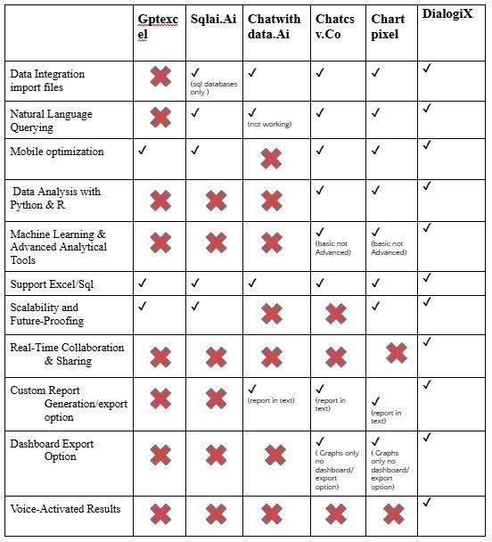
  - Gap Analysis

Despite advancements, several gaps remain in existing solutions:

Data Integration: Limited multi-source integration restricts usability. DialogixAI will offer robust connectors to diverse data sources and automated data cleaning.
Advanced Analytics: Few platforms support complex ML capabilities. DialogixAI will include AutoML and predictive analytics for deeper insights.

Visualization & UX: Existing platforms often lack interactive, customizable dashboards. DialogixAI will provide dynamic visualizations and storytelling modes for enhanced engagement.
Collaboration & Scalability: Real-time collaboration and scalability are limited. DialogixAI will support team collaboration and scalable, high-performance analysis.
Security: Many solutions lack advanced security. DialogixAI will implement strong access control, encryption, and compliance features.

CHAPTER 4

Software Engineering Methodology
- Planning Phase:
The project began with identifying the core objective — to develop an interactive AI-driven data analytics tool. Initial planning involved defining the target users, required features, and scope of the MVP (Minimum Viable Product).

Requirement Gathering:

Functional requirements like dashboard UI, AI chatbot, data filtering, and chart display were gathered.
Non-functional requirements such as responsiveness, speed, and user-friendly interface were also considered.

System Design:

The frontend architecture was planned using component-based design in React. Mockups and wireframes were created to visualize the flow of the application.
The use of TypeScript ensured type safety, and Vite was selected for faster build performance.

Implementation:

The project followed an incremental approach, where individual UI components and features were developed one by one and integrated progressively.
Emphasis was placed on modularity and reusability of components.

Testing:

Each component underwent manual testing to verify UI behavior and responsiveness. Debugging tools and browser dev tools were used during testing phases.

Review and Iteration:

Based on peer and supervisor feedback, improvements were made to the layout, interactions, and styling.

Continuous iterations allowed enhancing the UX progressively.

Project Methodology
- Planning Phase:
The project began with identifying the core objective — to develop an interactive AI-driven data analytics tool. Initial planning involved defining the target users, required features, and scope of the MVP (Minimum Viable Product).

Requirement Gathering:

Functional requirements like dashboard UI, AI chatbot, data filtering, and chart display were gathered.
Non-functional requirements such as responsiveness, speed, and user-friendly interface were also considered.

System Design:

The frontend architecture was planned using component-based design in React. Mockups and wireframes were created to visualize the flow of the application.
The use of TypeScript ensured type safety, and Vite was selected for faster build performance.

Implementation:

The project followed an incremental approach, where individual UI components and features were developed one by one and integrated progressively.
Emphasis was placed on modularity and reusability of components.

Testing:

Each component underwent manual testing to verify UI behavior and responsiveness. Debugging tools and browser dev tools were used during testing phases.

Review and Iteration:

Based on peer and supervisor feedback, improvements were made to the layout, interactions, and styling.Continuous iterations allowed enhancing the UX progressively.

Chapter 5

EXPERIMENTAL EVALUATIONS & RESULTS

  - Evaluation Testbed
The evaluation of DialogixAI was performed using a controlled testbed focused on the frontend’s functionality, performance, and user experience. The backend components were not yet integrated, so all evaluations centered on client-side capabilities.

Hardware & Software Configuration
System Specs:

OS: Windows 10

Processor: Intel Core i7 (11th Gen) RAM: 16 GB
Browser: Google Chrome (v122+) Development Stack:
ReactJS (TypeScript) with Vite TailwindCSS, ShadCN/UI for UI
Recharts and Chart.js for data visualization Context API for state handling

Dataset
Simulated business datasets (CSV/JSON formats)

Included fields like product name, sales, regions, and time periods

Test Participants
- users (students and faculty) interacted with the app and provided structured feedback.

Results and Discussion

    - User Interface Responsiveness
Initial Load Time: ~2.5 seconds

Component Interactivity: Real-time responsiveness with minimal delays

Chart Updates: Visualizations updated in <1 second upon filter interaction

Visualization Performance
Recharts and Chart.js worked well for real-time and interactive data charts. Tooltips, legends, and labels accurately reflected underlying data.
Multiple chart types (bar, line, pie) rendered cleanly.

AI Assistant Simulation
The AI chat interface allowed typed queries from users.
Although not connected to a backend NLP engine, simulated responses helped visualize expected functionality.
User input triggered mock logic such as: Data summarization
Trend suggestions
Column-specific filtering instructions

User Feedback Positive Aspects:
Clean and intuitive layout Helpful chart interactivity
Simple navigation between sections Suggestions for Improvement:
Add actual AI-powered responses
Enable live data input (via CSV drag-and-drop) Provide user onboarding or tooltip guidance

Identified Limitations

No real-time AI/NLP integration
No backend or persistent data handling
Not tested on very large datasets (>10,000 records)

CHAPTER 6

CONCLUSION AND DISCUSSION
  - Summary of Work
DialogixAI was developed as an AI-driven data analytics platform aimed at helping users interact with complex datasets through a smart, responsive, and user-friendly interface. The frontend was built using modern web technologies including React, TypeScript, and Vite. Core features such as dynamic data visualization, tabular filtering, and a prototype AI assistant were successfully implemented.

The system was evaluated for interface responsiveness, visualization accuracy, and usability. Feedback from initial users was largely positive, confirming that the application provides a smooth and intuitive data interaction experience. The foundation laid in the frontend phase paves the way for backend integration and advanced AI capabilities.

Limitations and Future Work
Limitations
No Backend Integration: The current version operates purely on frontend simulations, with no live connection to databases or AI models.

Mock AI Responses: The chatbot interaction is based on hardcoded or dummy responses and does not process real-time natural language queries.

Limited Dataset Handling: Performance testing was conducted on small to medium-sized datasets only; large-scale dataset handling remains untested.

No Authentication or User Management: Multi-user access control and session handling are not yet implemented.

Future Work
Backend Integration: Connect the frontend to a backend server (Node.js, Flask, or FastAPI) to enable real-time AI responses and persistent data storage.

AI Model Integration: Use large language models (like Hugging Face APIs) for meaningful, context-aware analytics assistance.

Authentication System: Add secure login, user sessions, and role-based dashboards.

Scalability Testing: Conduct performance and load testing with large enterprise datasets.

Export Features: Enable report generation and downloadable visualizations (e.g., export to PDF, Excel).

Reasons for Failure
While the project was largely successful in achieving its primary goals for the frontend, a few features could not be implemented due to time and resource constraints:

Live NLP Engine: Implementing a real-time AI assistant required more time and backend resources, which were not feasible within the FYP timeline.

Database Connectivity: Due to focus on frontend development, database integration was deferred.

Deployment Challenges: Full deployment was not completed, as the backend is pending and certain APIs are yet to be finalized.

Despite these minor setbacks, the core design and structure are fully extensible and ready for further development.

APPENDICES

List of Appendices

A0. Copy of Project Registration Form A1a. Project Proposal and Vision Document
A1b. Copy of Proposal Evaluation Comments by Jury A2. Requirement Specifications
A3. Design Specifications A4. Other Technical Details Test cases
UI/UX Details Coding Standards Project Policy
A5. Flyer & Poster Design
A6. Copy of Evaluation Comments
Copy of Evaluation Comments by Supervisor for Project – I Mid Semester Evaluation Copy of Evaluation Comments by Supervisor for Project – I End Semester Evaluation Copy of Evaluation Comments by Jury for Project – I End Semester Evaluation
Copy of Evaluation Comments by Supervisor for Project – II Mid Semester Evaluation Copy of Evaluation Comments by Jury for Project – II Mid Semester Evaluation
Copy of Evaluation Comments by Supervisor for Project – II End Semester Evaluation Copy of Evaluation Comments by Jury for Project – II End Semester Evaluation
A7. Meetings’ Minutes A8. Research Paper A10. Any other

A0. COPY OF PROJECT REGISTRATION FORM

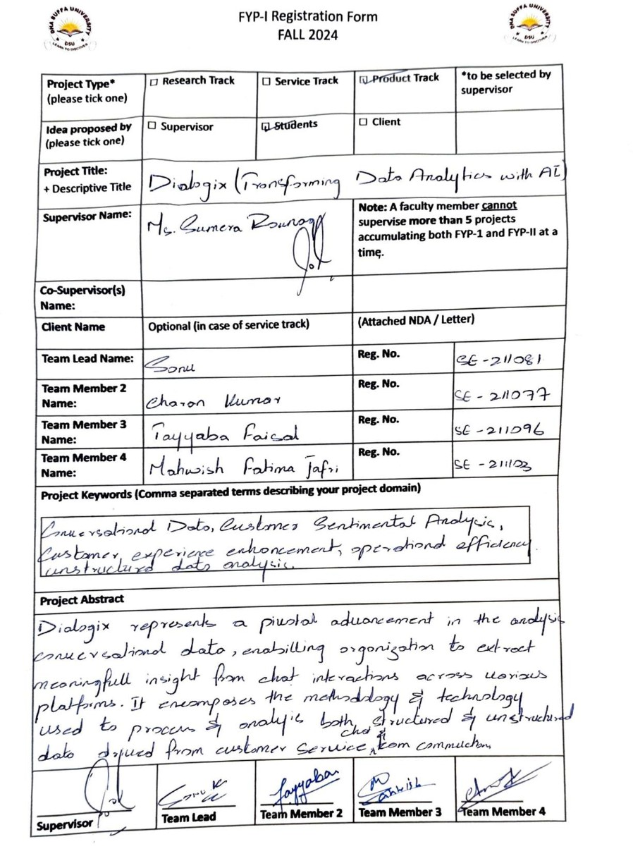

A1A. PROJECT PROPOSAL AND VISION DOCUMENT
- Introduction
  - Problem Statement
  - Project Motivation
  - Objectives
  - Literature Review
- Project Vision
  - Business Case and SWOT Analysis
  - Background, Business Opportunity, and Customer Needs
  - Business Objectives and Success Criteria
  - Project Risks and Risk Mitigation Plan
  - Assumptions and Dependencies 3 Project Scope
  - In Scope
  - Out of Scope
- Proposed Methodology
  - SDLC Approach (Waterfall/Agile/any model)
  - Team Role & responsibilities
  - Requirement Development
  - High-level Architecture / Design
4.6 Application (or Project) Testing 5 Project Planning
  - Gantt Chart
- Project Requirements
  - Software tools requirements
  - Hardware requirements
- Budget/Costing
  - Mention the budgeting cost of each item - required for this project
  - Estimated Budgeted Cost - of the Project 8 Project Deliverables
  - Phase I - Alpha Prototype
  - Phase II - Beta Prototype
  - Phase III - Release Candidate
  - Phase IV - Final Product
- Proposed GUI (Disposable Prototype)
- Meetings held with supervisor and/or client.
- Reference

Introduction
  - Problem Statement

DialogixAI simplifies advanced data analysis for businesses without data experts by offering an AI-powered platform that automates data cleaning, visualization, and predictive insights. Users can upload data, ask questions in natural language, and get instant visual answers making data-driven decisions easy and accessible.

Project Motivation

Dialogix aims to make data analytics accessible for non-technical users by using AI to automate data cleaning, analysis, and visualization. With features like natural language queries, predictive insights, dashboards, voice integration, and export options, it empowers users to make quick, informed decisions.

Objectives

    - Easy Data Import: Supports CSV and SQL with minimal setup.

    - Text & Sentiment Analysis: NLP-driven feedback insights.

    - Auto Data Cleaning: AI handles preprocessing and validation.

    - Threaded Replies: Respond directly to specific messages.

    - Interactive Dashboards: Real-time, filterable visualizations.

    - Auto Insights: AI highlights key trends and changes.

Literature Review

AI-powered analytics tools use NLP, machine learning, and visualization to make data insights accessible, but many still lack robust data integration, real-time collaboration, and advanced ML features. Tools like ChatCSV.co and SQLAI.ai offer basic analysis but don’t fully support multi-source import, auto-cleaning, predictive analytics, and dynamic visuals.

Project Vision
  - Business Case and SWOT Analysis

Dialogix is an AI-powered analytics platform designed for non-technical users, offering easy data import, automated cleaning, natural language queries, predictive analytics, and interactive visualizations. Targeting SMBs and marketing teams, it addresses the growing need for accessible data tools without requiring data experts. With a user-friendly interface, voice-based results, and a phased implementation plan, Dialogix aims to lead the business intelligence market. Backed by market research, user feedback, and strategic partnerships, it ensures product-market fit while promoting sustainable, data-driven decision-making.

  - Background, Business Opportunity, and Customer Needs
  - Business Objectives and Success Criteria

Business Objectives:
Dialogix aims to deliver actionable insights using NLP and augmented analytics like "what-if" analysis, enabling informed, agile decision-making. It targets SMBs and non-technical users with a user-friendly platform that eliminates the need for data experts.

Success Criteria:
High user adoption through an intuitive interface; accurate, fast data processing (under 10 seconds); predictive analytics with 80%+ accuracy; and timely AI-generated insights and alerts for key trends and anomalies.

Project Risks and Risk Mitigation Plan

Risks include technical glitches, strong market competition, user adoption barriers, and limited collaboration. Mitigation involves thorough testing (CI/CD), unique AI features with voice support, intuitive UI with tutorials and freemium access, and real-time collaboration tools with continuous user feedback.

Assumptions and Dependencies

Assumes users have stable internet, modern devices, and growing smartphone access. AI models are expected to perform effectively. Success depends on reliable tech infrastructure, quality training data, and active user engagement.

Project Scope

Easy data import from sources like Google Sheets, SQL, and CRMs; AI-powered data cleaning; natural language and voice-activated queries; predictive analytics and anomaly detection; interactive dashboards; industry-specific models; exportable reports; and full mobile optimization with user-friendly guidance.

In Scope

    - Data Integration & AI Cleaning.
    - Interactive Dashboards & Collaboration.
    - Scalability & Performance Optimization
    - Mobile Optimization

Out of Scope

    - Third-Party Integrations
    - Custom AI Model Development
    - Data Governance & Compliance
    - Offline Functionality
    - User Support & Training

Proposed Methodology
  - SDLC Approach (Waterfall/Agile/any model)

For our FYP project, the most suitable SDLC approach would be Agile due to its flexibility, iterative nature, and ability to accommodate changes and evolving requirements throughout the development process

Team Role & responsibilities

Supervisor- Ms. Sumera Rounaq
Name - Sonu (Leader)
Responsibilities -Integrate data import, AI preprocessing, and natural language query processing via APIs.
Name – Tayyaba Faisal
Responsibilities - Develop, optimize, and integrate machine learning models for forecasting and analytics.
Name – Mahwish Fatima Jafri
Responsibilities - Design and implement an intuitive, interactive UI for data import, querying, and result visualization.

Requirement Development

Use Kaggle datasets, public APIs, and user-imported data (CSV, Excel, SQL). Clean and preprocess data with techniques like normalization and feature engineering. Conduct market research and gather user requirements to guide AI feature development. Ensure operational feasibility and design an intuitive UI/UX for data import, querying, and visualization.

High-level Architecture / Design
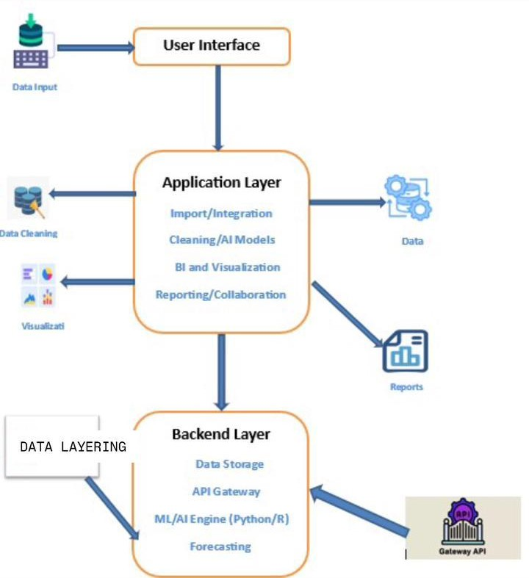
4.6 Application (or Project) Testing

Unit tests verify each component of DialogixAI, while integration tests ensure smooth interaction between modules. For predictive analytics, white-box testing checks algorithm logic and setup to ensure accurate forecasting and anomaly detection.

- Project Planning
  - Gantt Chart

- Project Requirements.

  - Software tools requirements

Google Colab (model training), PyTorch/TensorFlow (ML/DL), MS Office (documentation), React (web UI).

Hardware requirements

Smartphones (mobile access), PCs (development/use), GPU (efficient model training).

Budget/Costing
  - Mention the budgeting cost of each item - required for this project

    - GPU – Rs. 250,000
    - PC – Rs. 100,000
    - Smartphone – Rs. 70,000
    - Other resources – Rs. 18,000

Estimated Budgeted Cost - of the Project

    - Total Hours – 1080 hrs
    - Per Hour Rate – Rs. 300
    - Total Hours Rate – Rs. 324,000
    - Hardware Cost – Rs. 438,000
    - GPU – Rs. 250,000
    - PC – Rs. 100,000
    - Smartphone – Rs. 70,000
    - Other resources – Rs. 18,000
    - Total Cost Rs. 762,00

- Project Deliverables
  - Phase I - Alpha Prototype

The Alpha prototype focuses on developing the core features of the platform, including basic data import, cleaning, and visualization functionalities. This phase is primarily for internal testing and gathering initial feedback from a small group of users.

Phase II - Beta Prototype

The Beta prototype expands on the Alpha by integrating additional features like AI-driven insights. A larger user base will test this version, providing valuable feedback for further refinement.

Phase III - Release Candidate

The Release Candidate phase involves finalizing the platform’s features and preparing for launch. This version will undergo rigorous testing to ensure stability, security, and scalability

Phase IV - Final Product

The Final Product is the fully functional, production-ready version of the platform, ready for public release. It includes all planned features and optimizations, with ongoing maintenance and support for future updates

Proposed GUI (Disposable Prototype)



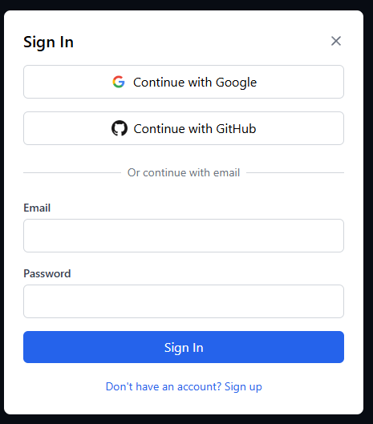

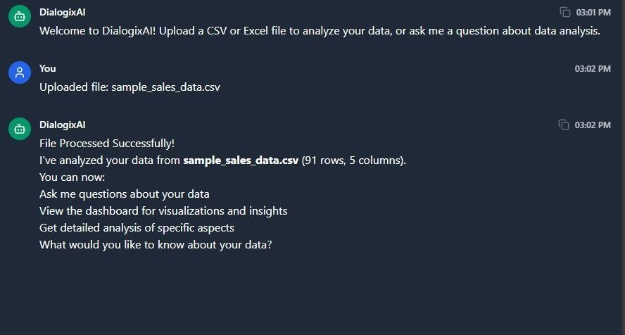

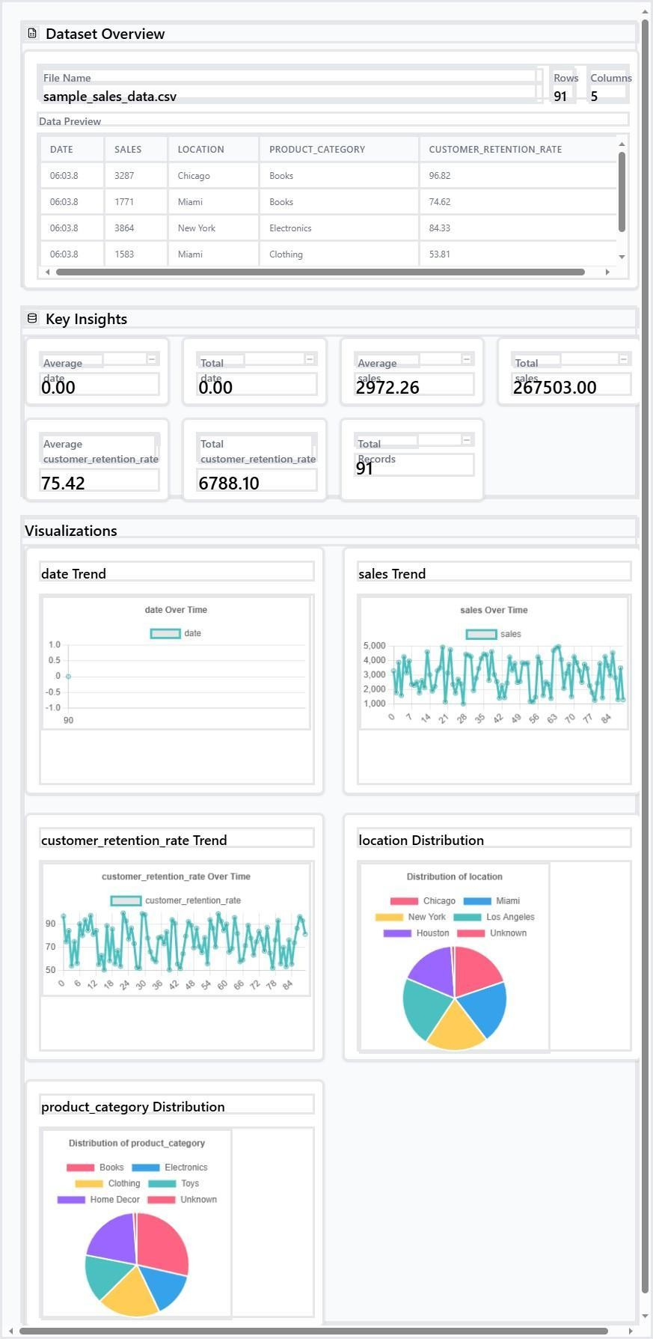



- Meetings held with supervisor and/or client.

Meeting with Supervisor (07/10/24)
Discussion regarding proposal - project risks, and scope, and verify and check of work done.

Meeting with Supervisor (07/10/24)
Discussion regarding proposal - implementing methodology, project hierarchy, project requirements and deliverables, and proofreading

Meeting with Supervisor (21/10/24) Review finalized proposal
Get approval for methodology and feature set Discuss project timeline and milestones

Meeting with Supervisor (04/11/24) Demonstrate basic UI/UX wireframes
Discuss data collection sources and tools Finalize tools and technologies

Meeting with Supervisor (18/11/24)
Present progress on frontend development (React) Show initial data import & cleaning functionality Review user requirement alignment

Meeting with Supervisor (02/12/24)
Review integration of NLP and ML models
Evaluate preliminary predictive analytics results Collect feedback for improvement

Meeting with Supervisor (16/12/24)
Test early version of natural language querying Demonstrate voice response functionality
Review interactive dashboard mockups

Meeting with Supervisor (06/01/25)
Full walkthrough of data flow: import → cleaning → analysis → insights Conduct internal test cases (white-box testing updates)
Review accuracy metrics for predictive analytics

Meeting with Supervisor (20/01/25)
Discuss user feedback collection plans Finalize reporting formats (PDF/Excel)
Evaluate mobile responsiveness and accessibility

Meeting with Supervisor (17/02/25) Conduct supervised testing phase
Gather supervisor’s evaluation on performance and usability Begin report writing and documentation

Meeting with Supervisor (03/03/25) Submit draft of final project report Receive feedback and corrections Final UI polishing and bug fixes

Meeting with Supervisor (12/03/25) Final submission of project
Supervisor's final evaluation and sign-off Discuss presentation prep for viva/defense

Reference
- Chat with Data
Chat with Data. "Home." Accessed November 13, 2024. https://chatwithdata.ai/home.

DataGPT
DataGPT. "Home." Accessed November 13, 2024. https://datagpt.com/.

A1B. COPY OF PROPOSAL EVALUATION COMMENTS BY JURY

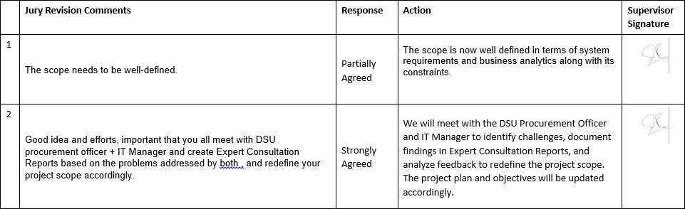

A2. REQUIREMENT SPECIFICATIONS
- Introduction
  - Purpose of Document
  - Intended Audience
- Overall System Description
  - Project Background
  - Project Scope
  - Not In Scope
  - Project Objectives
  - Stakeholders
  - Operating Environment
  - System Constraints
  - Assumptions & Dependencies
- External Interface Requirements
  - Hardware Interfaces
  - Software Interfaces
  - Communications Interfaces
- Functional Requirements
  - Performance Requirements
  - Design Constraints
  - Programming Language
  - Interface Requirements
  - Use Cases
    - List of Actors
    - List of Use Cases
    - Use Case Diagram
    - Description of Use Cases
- Non-functional Requirements
  - Performance Requirements
  - Safety Requirements
  - Security Requirements
  - Reliability Requirements
  - Usability Requirements
  - Supportability Requirements
  - User Documentation
- References

Introduction

  - Purpose of Document

The purpose of this document is to define the requirements of the proposed project as outlined in the project proposal document. It ensures all stakeholders have a clear understanding of the system to be developed.

Intended Audience

Project Team Members: Developers, data scientists, and UX designers responsible for building the chatbot.
Business Analysts: The end users who will use Dialogix to interact with data. Project Sponsors and Stakeholders: Individuals or organizations funding the project who need an understanding of its development process.

Overall System Description
  - Project Background
In today’s data-driven world, businesses generate vast amounts of data but often struggle to extract actionable insights without specialized data analysts. This project is motivated by the need to make data analytics accessible to non-technical users. The proposed application, Dialogix, will use AI to simplify data tasks such as cleaning, analysis, and visualization. Features like natural language querying, interactive dashboards, and automated insights will empower users to make data-driven decisions quickly and efficiently, while export option enhance accessibility and communication.

Problem Statement
The problem that DialogixAI aims to solve is the complexity and inaccessibility of advanced data analysis for businesses that lack dedicated data analysts. Many organizations struggle to leverage their data effectively due to the technical skills required for cleaning, processing, and visualizing data. DialogixAI seeks to bridge this gap by providing a user-friendly, AI-powered data analytics platform that automates these tasks, making it easy for users to upload data, ask questions in natural language, and instantly receive visual insights and answers. This platform not only simplifies the entire data workflow from data

integration and preparation to visualization and reporting but also includes advanced analytics, such as anomaly detection, to enable informed decision-making without the need for specialized data expertise.

Project Scope
Easy Data Import & Integration: Simplified connectors to import data from various sources like CSV and SQL databases minimizing setup time.
Automated Data Cleaning & Preprocessing: AI-powered tools that automatically clean and prepare data, allowing users to focus on analysis rather than manual data wrangling.
Natural Language Querying: A user-friendly interface where users can ask questions in plain language (e.g., “What were the sales trends last quarter?”) and receive instant answers with visualizations.
Interactive Dashboards & Visualizations: Real-time, interactive dashboards with drill-down capabilities, offering customizable and visually compelling charts and graphs to communicate complex insights in a simple, intuitive way.
Industry-Specific Features: Pre-built models tailored to specific industries like healthcare, finance, and e-commerce, offering insights that are relevant and actionable for sector-specific needs.
Mobile Optimization & User Support: The platform will be optimized for mobile use, ensuring a seamless experience across devices, with built-in tutorials and interactive guidance to assist even beginner users

Not In Scope

- Third-Party Integrations
- Custom AI Model Development
- Data Governance & Compliance
- Offline Functionality
- User Support & Training

Project Objectives

Effortless Data Integration: Seamlessly import data from sources like CSV and SQL databases with minimal setup.
Natural Language Querying: Users can ask questions in everyday language and get instant, clear responses.
Sentiment and Text Analysis: Use NLP to analyze text data for sentiment and themes, offering customer feedback insights.
Automated Data Cleaning and Preparation: AI-driven cleaning, preprocessing, and validation of data, reducing manual handling.
Interactive and Dynamic Dashboards: Real-time dashboards with dynamic filters and drill-down features.
Automated Insights Generation: AI scans data to highlight significant trends or changes and alert users.
Augmented Analytics: "What-If" analysis to evaluate potential impacts of different business decisions.

Mobile Optimization and Accessibility: Fully responsive design for mobile device access. Collaborative and Transparent Environment: Collaboration, sharing insights, and automated data documentation for transparency.
Scalability and Future-Proofing: Platform designed for scalability, modularity, and easy integration of future technologies.
Reporting and Export Options: Generate and export custom reports in PDF, Excel, or CSV.

Stakeholders & Affected Groups

The primary stakeholders of DialogixAI include end users, data analysts, and machine learning experts. End users, such as business professionals or students, will rely on DialogixAI to import data, analyze insights, generate reports, and collaborate effectively. Data analysts, who utilize the platform for data analysis tasks, contribute by providing feedback on usability and functionality, defining data requirements, and assisting in testing features like querying, anomaly detection, and visualization. Machine learning experts, either internal or external consultants, play a critical role in integrating machine learning models for anomaly detection. They ensure the accuracy and performance of these algorithms to maintain the overall quality and reliability of the system.

Operating Environment

The operating environment refers to the conditions and context in which the system will function. This includes:
- Hardware Requirements: Specific devices, processors, and memory configurations necessary for efficient system operations.
- Software Compatibility: The operating systems, programming environments, or frameworks in which the system will be deployed. For example, Windows/Linux/Mac OS platforms with appropriate runtime environments.
- Networking Infrastructure: The type of network (LAN, WAN, cloud-hosted) required
for the system to connect and communicate efficiently.
- User Interaction Interfaces: Web or mobile interfaces where end-users interact with the system.
- Physical Environment: Conditions like temperature, humidity, or power availability, if applicable to hardware-based systems.

System Constraints

System constraints define the limitations or boundaries within which the project must operate:
- Hardware Limitations: Available memory, processor speed, or storage capacity that could restrict system performance.
- Software Restrictions: Compatibility with only specific versions of operating systems, databases, or third-party software.
- Budgetary and Time Constraints: Financial and temporal limitations that restrict
development and deployment.
- Compliance and Regulatory Standards: Adherence to data protection, security, or other statutory requirements.
- Scalability and Extensibility: Limits on the system’s ability to grow or integrate new
features without substantial redevelopment.

Assumptions & Dependencies

This section identifies assumptions made during the project planning and dependencies that could impact its execution:

Assumptions:
  - Users have basic technical knowledge to operate the system.
  - The required hardware and network infrastructure will be in place before deployment.
  - Adequate funding and resources are available for project completion.

Dependencies:
  - Availability of third-party APIs or software for integration.
  - Reliable and consistent network connectivity for online operations.
  - Vendor or supplier commitments for hardware or software components.
  - Stakeholder involvement in testing and feedback.

- External Interface Requirements
  - Hardware Interfaces
Smartphones
- Logical Structure: Smartphones serve as client devices for accessing the DialogixAI platform via a mobile-friendly interface. Communication between the mobile app and the server uses APIs over secure protocols (e.g., HTTPS).
- Physical Addresses: Mobile devices communicate with the server using their unique IP
addresses assigned within the network.
- Expected Behavior: The system provides responsive design and real-time synchronization, allowing users to import data, view reports, and collaborate seamlessly while maintaining optimal performance on smaller screens.

PCs
- Logical Structure: PCs act as both development and client machines for DialogixAI. The platform is accessed through a web interface or desktop application, supporting rich functionality for testing, interface design, and data analysis.
- Physical Addresses: PCs use static or dynamic IP addresses depending on the network
setup and interact with servers via standard network protocols.
- Expected Behavior: PCs offer full access to all system features, including advanced configuration, data processing, and visualization tools, ensuring a robust user experience for professionals and developers.

GPU

- Logical Structure: GPUs are integrated as computational units for intensive tasks such as model training, deep learning, and large-scale data processing. The system interacts with GPUs via machine learning frameworks (e.g., TensorFlow or PyTorch) and APIs like CUDA or OpenCL.
- Physical Addresses: GPUs are accessed through the hardware bus addresses (e.g., PCIe
slots) and identified by unique device IDs within the system.
- Expected Behavior: The system optimizes GPU utilization for parallel processing, significantly accelerating tasks like predictive analytics, anomaly detection, and visualization rendering while minimizing latency and resource overhead.

Software Interfaces

DialogixAI integrates with various external libraries and services to provide seamless data analysis, visualization, and reporting capabilities. Below are the primary technologies and how they interact with the system:

React
- External Owner: Meta Platforms, Inc.

- Interface Details: React is used to build the frontend of DialogixAI. It communicates with the backend through Supabase’s JavaScript SDK to fetch and display data, ensuring a responsive and cross-browser-compatible UI.

Supabase
- External Owner: Supabase Inc.

- Interface Details: Supabase handles backend services, including user authentication, PostgreSQL database storage, and file uploads. DialogixAI interacts with Supabase via RESTful API calls and real-time subscriptions for dynamic data updates.

Chart.js
- External Owner: Chart.js Contributors

- Interface Details: Chart.js is used to render interactive charts and graphs. It integrates directly with React components to visualize user-uploaded data in dashboards.

dom-to-image-more
- External Owner: Community Developers (Open Source)

- Interface Details: Used to export dashboard views as images (e.g., PNG). It captures DOM elements from the UI and enables users to download visual reports.

Microsoft Office
- External Owner: Microsoft Corporation

- Interface Details: DialogixAI allows users to upload .xlsx and .csv files from Excel for analysis. Direct integration with Microsoft Graph API is not currently implemented but may be considered in future versions.

Communications Interfaces

Communication interfaces define the methods, protocols, and technologies that a system uses to exchange data with other systems, devices, or networks. These interfaces ensure seamless interaction between hardware, software, and users while maintaining data integrity and security. Common types of communication interfaces include:

Hardware Interfaces:
  - Physical connections such as Ethernet ports, USB, and HDMI.
  - Networking devices like routers, switches, and hubs.

Software Interfaces:
  - Application Programming Interfaces (APIs) that enable communication between software components or systems.
  - Protocols like HTTP, MQTT, and WebSockets for data exchange over networks.

Communication Protocols:
  - TCP/IP, UDP: Essential for data transmission across IP-based networks.
  - FTP, SFTP: For file transfers between systems.
  - SNMP: Used for network management and monitoring.

Integration with Local Area Networks (LANs)

A Local Area Network (LAN) is a network infrastructure that connects multiple devices within a limited geographical area, such as an office or home. Communication interfaces facilitate the integration of systems and devices with a LAN, enabling efficient data sharing and collaboration. Key aspects include:

Physical Integration:
  - Devices are connected via Ethernet cables or Wi-Fi to the LAN.
  - Network Interface Cards (NICs) in devices ensure compatibility with the

LAN’s infrastructure.

Network Configuration:
  - Devices communicate using a unique IP address assigned by the LAN's DHCP server.
  - Subnet masks and gateways define routing paths within the LAN.

Data Exchange:
  - Systems use LAN protocols like Ethernet for high-speed data transfer.
  - APIs and middleware enable seamless data exchange between applications and networked devices.

Security and Access Control:
  - Secure protocols such as HTTPS

Scalability and Performance:
  - LANs provide scalable infrastructure with minimal latency, making them suitable for real-time communication and data-intensive applications.
  - Tools like QoS (Quality of Service) prioritize critical data traffic.

Communication Protocols:
  - TCP/IP, UDP: Essential for data transmission across IP-based networks.
  - FTP, SFTP: For file transfers between systems.
  - SNMP: Used for network management and monitoring.

Integration with Local Area Networks (LANs)

A Local Area Network (LAN) is a network infrastructure that connects multiple devices within a limited geographical area, such as an office or home. Communication interfaces facilitate the integration of systems and devices with a LAN, enabling efficient data sharing and collaboration. Key aspects include:

Physical Integration:
  - Devices are connected via Ethernet cables or Wi-Fi to the LAN.
  - Network Interface Cards (NICs) in devices ensure compatibility with the LAN’s infrastructure.

Network Configuration:
  - Devices communicate using a unique IP address assigned by the LAN's DHCP server.
  - Subnet masks and gateways define routing paths within the LAN.

Data Exchange:
  - Systems use LAN protocols like Ethernet for high-speed data transfer.

  - APIs and middleware enable seamless data exchange between applications and networked devices.

Security and Access Control:
  - Secure protocols such as HTTPS

Scalability and Performance:
  - LANs provide scalable infrastructure with minimal latency, making them suitable for real-time communication and data-intensive applications.
  - Tools like QoS (Quality of Service) prioritize critical data traffic.

- System Functions / Functional Requirements

Ref# | Functions | Category | Attribute | Details & Boundary Constraints
R1.1 | Import data from various  sources such as CSV, Excel andSQL  databases | Evident | System response time | Data imported and validated within 5 seconds for datasets under 10MB.
R1.2 | Automatically clean  and preprocess imported  data for  analysis. | Hidden | Data preprocessing time | Data cleaning process should complete within 10 seconds for datasets under 10MB
R1.3 | Enable users to query data in plain language. | Evident | NLP  response time | Response to natural language  queries generated within 3 seconds.
R1.4 | Generate  dashboards with dynamic  visualizations  like graphs and charts. | Evident | Rendering time | Dashboard visualization should render within 5 seconds after user selection.

R1.5 | Detect  anomalies in data  trends or patterns  automatically. | Hidden | Detection accuracy | System should identify anomalies with at least 95% precision and recall.
R1.6 | Offer custom report generation in  formats like  PDF and Excel. | Evident | File  generation time | Reports generated and available for download within 10 seconds.
R1.7 | Allow real-time collaboration and sharing of dashboards  and reports. | Evident | Concurrent user load | Up to 20 users can collaborate simultaneously with seamless data synchronization
R1.8 | Perform sentiment  analysis on textual data to extract customer  opinions. | Hidden | Sentiment analysis accuracy | Accuracy of sentiment classification should be at least 90%.
R1.9 | Provide automated insights  generation by  scanning for relevant trends and metrics. | Hidden | Insights  relevance score | Insights should achieve at least 90% user satisfaction rating in relevance tests.

  - System Attributes/ Nonfunctional Requirements

Attribute | Details and Boundary Constraints | Category
Response time | Responses to user interactions must complete within 5 seconds for smooth usability. | Mandatory
Concurrent User Load | Support a minimum of 20 simultaneously. | Mandatory
Availability | System uptime of 99.9% during operational hours. | Mandatory
Scalability | Must handle datasets up to 1GB without degradation in performance. | Mandatory

Ease of Use | User interface should be intuitive, requiring no prior technical expertise to navigate. | Optional
Security | Data storage and communication should be secure | Mandatory

  - Use Cases
    - List of Actors
System Boundary: The DialogixAI platform includes modules for data import, processing, analysis, visualization, and collaboration tools.

Actors:
End User: Business professionals or students using the system for importing data, analyzing insights, generating reports, and collaborating.
Data Analyst: Individuals providing feedback on usability, defining data requirements, and testing analysis features.
Machine Learning Expert: Consultants integrating machine learning models for tasks such as predictive analytics and anomaly detection.

Administrator: Responsible for managing user accounts, system configurations, and overall system health.
External API System: Interfaces with cloud-based services like Google Colab or Microsoft Office for data sharing and processing.
IoT Device: Hardware providing real-time data inputs for analysis

List of Use Cases
Import Data: Allows users to upload data files in various formats (e.g., CSV, Excel) for analysis.
Perform Data Analysis: Users can apply predefined or custom analytical models to uploaded datasets.
Generate Reports: Generates visual and tabular reports based on processed data.
Collaborate: Enables users to share data, insights, and reports with others using links.
Integrate ML Models: Facilitates the integration of external machine learning models for analysis.
Manage User Accounts: Administrators can create, update, and delete user accounts and assign roles.
Access Mobile Interface: Allows users to access the system via smartphones for on-the-go analysis.
Real-Time Data Processing: Supports IoT devices for continuous data input and real-time visualization.
Export Results: Provides functionality to export results in multiple formats (e.g., PDF, Excel).

Use Case Diagram

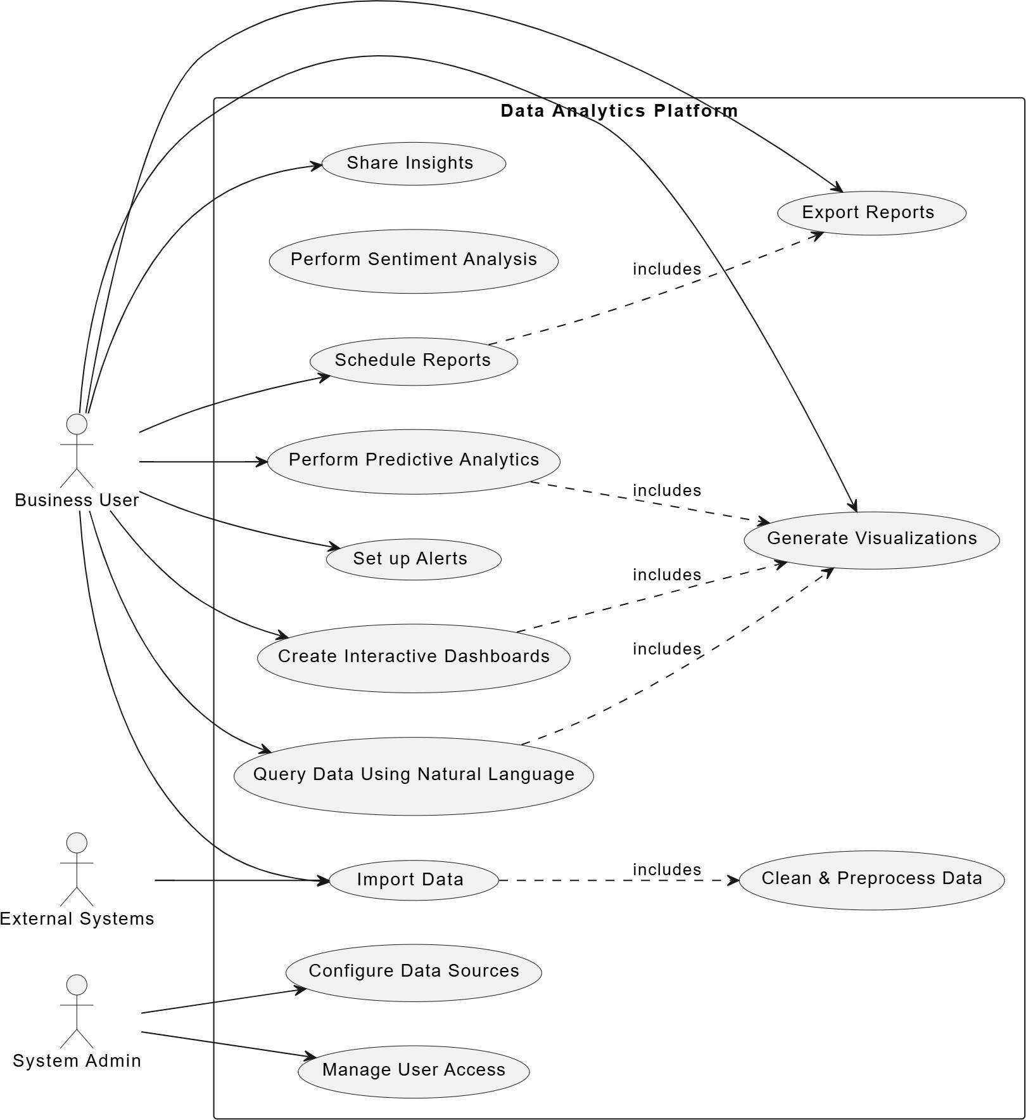

    - Description of Use Cases
Use Case: Share Insights Actors: Business User
Description: The Business User shares analytical insights derived from the platform with stakeholders or other collaborators.

Pre-Conditions:
      - Insights are available from the analysis.
      - User has appropriate access to sharing tools.

Post-Conditions:
      - Insights are successfully shared.
      - Stakeholders can view the shared insights.

Typical Steps:

- The Business User selects the insights to share.
- The platform facilitates sharing through email, reports, or integrations.
- Confirmation is sent to the user. Use Case: Perform Sentiment Analysis Actors: Business User
Description: The Business User runs sentiment analysis on the dataset to derive opinions or attitudes.

Pre-Conditions:
  - Data has been imported and preprocessed.
  - Sentiment analysis tools are configured.

Post-Conditions:
  - Results of sentiment analysis are available for review.

Typical Steps:

- The Business User selects the dataset.
- The platform applies sentiment analysis algorithms.
- Results are displayed to the user.

Use Case: Schedule Reports Actors: Business User
Description: The Business User schedules periodic reports to be generated and sent automatically.

Pre-Conditions:
  - Report templates are available.

Post-Conditions:
  - Reports are generated and sent according to the schedule.

Typical Steps:

- The Business User selects a report template.
- The user configures the frequency and recipients.
- The platform generates and sends the reports.
Use Case: Perform Predictive Analytics Actors: Business User
Description: The Business User runs predictive analytics models on the data to forecast future trends or outcomes.

Pre-Conditions:
  - Data is prepared and cleaned.

Post-Conditions:
  - Predictive results are displayed to the user.

Typical Steps:

- The user selects the dataset and model.
- The platform processes the data.

Actors: Business User
Description: The Business User sets up alerts for specific triggers or conditions in the data.

Pre-Conditions:
  - Data is being monitored.

Post-Conditions:
  - Alerts are configured and active.

Typical Steps:

- The user defines the conditions for alerts.
- The platform monitors data for the conditions.
- Alerts are sent when the conditions are met.
Use Case: Create Interactive Dashboards Actors: Business User
Description: The Business User creates dashboards with visualizations and real-time data interactivity.

Pre-Conditions:
  - Data is imported and processed.

Post-Conditions:
  - Interactive dashboards are created and functional.

Typical Steps:

- The user selects data and visualization types.
- The platform generates the dashboard.
- The user customizes and saves the dashboard. Use Case: Query Data Using Natural Language Actors: Business User
Description: The Business User queries the dataset using natural language processing tools.

Pre-Conditions:
  - NLP query tools are operational.

Post-Conditions:
  - Results of the query are displayed to the user.

Typical Steps:

- The user inputs a query in natural language.
- The platform interprets the query and retrieves data.
- Results are shown to the user.

Use Case: Import Data

Actors: Business User, External Systems
Description: Data is imported into the platform for analysis.

Pre-Conditions:
  - Data sources are accessible.

Post-Conditions:
  - Data is successfully imported.

Typical Steps:

- The user connects to the data source.
- Data is imported into the platform.
- Imported data is ready for processing. Use Case: Clean & Preprocess Data Actors: Business User
Description: Imported data is cleaned and prepared for analysis.

Pre-Conditions:
  - Data has been imported.

Post-Conditions:
  - Data is preprocessed and ready for analysis.

Typical Steps:

- The user selects the dataset.
- The platform applies cleaning and preprocessing algorithms
- Cleaned data is saved for further use. Use Case: Configure Data Sources Actors: System Admin
Description: System Admin configures connections to external data sources.

Pre-Conditions:
  - Access to external systems is available.

Post-Conditions:
  - Data sources are configured and accessible.

Typical Steps:

- The admin connects the platform to data sources.
- Configuration settings are applied.
- Connection status is verified.
Use Case: Manage User Access Actors: System Admin
Description: The System Admin manages user roles and permissions for platform access.

Pre-Conditions:
  - Admin access is granted.

Post-Conditions:
  - User access levels are updated.

Typical Steps:

- The admin selects a user or group.
- Permissions and roles are assigned or modified.
- Changes are saved and applied.

Non - Functional Requirements

  - Performance Requirements

The system is expected to meet the following performance metrics to ensure operational efficiency:
- Response Time: All user interactions must have a response time of less than 5 seconds for seamless usability.
- Throughput: The system must handle a minimum of 10 concurrent users, with scalable support for up to 20 users without performance degradation.
- System Capacity: Data imports and processing tasks should handle datasets up to
1GB efficiently.

Safety Requirements

To ensure safe operations for users and the environment:
- Error handling mechanisms must prevent data loss during system crashes.
- Fail-safe procedures should ensure that incomplete transactions do not corrupt system integrity.
- Compliance with safety standards, such as GDPR, for data protection.

Security Requirements

The system must adhere to strict security protocols to prevent unauthorized access:
- User Authentication: Multi-factor authentication must be implemented for all users.
- Auditing: Maintain logs of all user activities and access events for auditing purposes.

Reliability Requirements

Reliability is critical to the system’s consistent operation:
- Uptime: The system must maintain an uptime of 99.9% during operational hours.
- Error Tolerance: Handle up to 10% unexpected errors gracefully without user disruption.
- Recovery Time: System recovery from failures must occur within 2 minutes.

Usability Requirements

The system must prioritize user experience:
- An intuitive interface should require minimal training for users to operate effectively.
- Accessibility features, such as voice feedback and keyboard navigation, must be included.
- The platform must provide multi-language support for diverse user groups.

Supportability Requirements

For ease of maintenance and updates:
- System Updates: The system must support hotfixes and patches with minimal downtime.
- Technical Documentation: Provide detailed technical manuals for developers and administrators.
- Customer Support: A dedicated support portal with FAQs and troubleshooting guides.

User Documentation

To assist end users in utilizing the system:
- Guides: Comprehensive guides for performing data imports, running analytics, and generating reports.
- Feature Documentation: Detailed explanations of advanced features like predictive analytics, anomaly detection, and natural language querying.
- Tutorials: Interactive tutorials and video walkthroughs for common workflows.
- FAQs: An in-app FAQ section for addressing frequently encountered issues.

A3. DESIGN SPECIFICATIONS
- Introduction
  - Purpose of Document
  - Intended Audience
  - Project Overview
  - Scope
- Design Considerations
  - Assumptions and Dependencies
  - Risks and Volatile Areas 3 System Architecture
  - System Level Architecture
  - Software Architecture
- Design Strategy
- Detailed System Design
  - Design Class Diagram
  - Database Design
  - ER Diagram
  - Application Design
  - GUI Design
- References

Introduction

  - Purpose of Document

The purpose of this document is to provide a detailed software design specification for the "Dialogix" project, an AI-powered data analytics platform designed to simplify data processing, analysis, and visualization for non-technical users.

Intended Audience
Project Team Members: Developers, data scientists, and UX designers responsible for building the chatbot.
Business Analysts: The end users who will use Dialogix to interact with data. Project Sponsors and Stakeholders: Individuals or organizations funding the project who need an understanding of its development process.

Document Convention

Font Style: Times New Roman

Font Size: 12pt for body text, 15pt for headings.

Project Overview

Dialogix is a data analytics chatbot designed to streamline interactions between business analysts and their data. It simplifies complex SQL queries by translating natural language inputs into actionable insights and database queries.

Functionality:
    - Supports conversational data querying.
    - Provides AI-driven insights and recommendations.
    - Generates visualizations such as graphs and dashboards based on user queries.

Basic Design Approach:

The chatbot integrates advanced natural language processing (NLP) models for understanding user queries, and it interacts with databases through APIs to retrieve and present data. A modular architecture ensures scalability, while a user-friendly interface guarantees ease of use for business analysts.

Scope

In Scope

The Dialogix will
- Allow users to import data from various sources such as Google Sheets, SQL databases, and cloud storage.
- Perform automated data cleaning and preprocessing.
- Enable conversational queries using natural language processing.
- Generate real-time visualizations and interactive dashboards.
- Provide anomaly detection.
- Offer export options in formats like CSV, Excel, and PDF.
- Support machine learning capabilities for advanced analytics.

Out of Scope
What dialogix will not do

- Manual data cleaning or transformation.
- Development of non-data-related chatbot functionalities (e.g., general conversation bots).
- Hosting or managing user data on private servers unless specified.
- Real-time integrations with unsupported proprietary software.

Design Considerations
The considerations aim to ensure scalability, usability, security, and alignment with user requirements.
- User-Friendliness: The system must accommodate users with minimal
technical knowledge, ensuring a seamless and intuitive interface.
- Scalability: The design must allow for future enhancements, such as additional data connectors or integration with new machine learning algorithms.
- Performance: The system should handle large datasets efficiently while
maintaining low response times for natural language queries.
- Security: Data protection through encryption, access control, and compliance with industry standards must be integral to the design.
- Interoperability: The design must enable integration with third-party tools and support various data formats.

Assumptions and Dependencies Assumptions:

    - Users have access to structured data in supported formats (e.g., CSV, SQL databases).
    - Internet connectivity is required for cloud-based features and integrations.
    - NLP performance is contingent on the quality of pre-trained language models like ChatGPT.

Dependencies:

    - The system relies on APIs for integrating external data sources (e.g., Google Sheets, cloud storage).
    - Open-source libraries and frameworks (e.g., Python libraries, visualization tools) will be critical for development.
    - Third-party machine learning models may be used for specific features like anomaly detection and predictive analytics.

Risks and Volatile Areas Risks

- Technology Risk: Dependence on third-party APIs or frameworks may result in disruptions if the service is discontinued or altered.
- Performance Risk: Handling very large datasets may pose performance challenges, potentially leading to latency or system crashes.
- Security Risk: Inadequate safeguards may expose sensitive data to unauthorized access, leading to compliance issues.
- User Adoption Risk: If the interface is not intuitive, users may find it challenging to adopt the system, impacting its overall success.

Volatile Areas

- New Requirements: Future demands for additional features (e.g., advanced visualization tools, more ML algorithms) may require significant design changes.
- Technology Evolution: Advances in AI and ML may render current models or frameworks obsolete, requiring timely upgrades.
- Regulatory Changes: Changes in data protection laws could necessitate modifications in how data is processed and stored.

Contingency Measures

- Modular Design: The system will be designed modularly, allowing components to be updated or replaced independently.
- Scalable Infrastructure: Cloud-based architecture will be used to handle increased workloads and data volumes.
- Regular Updates: The design will include mechanisms for regularly updating third-party tools and APIs.
- Prototyping and Feedback: Early prototyping and regular user feedback will help address usability risks.

System Architecture

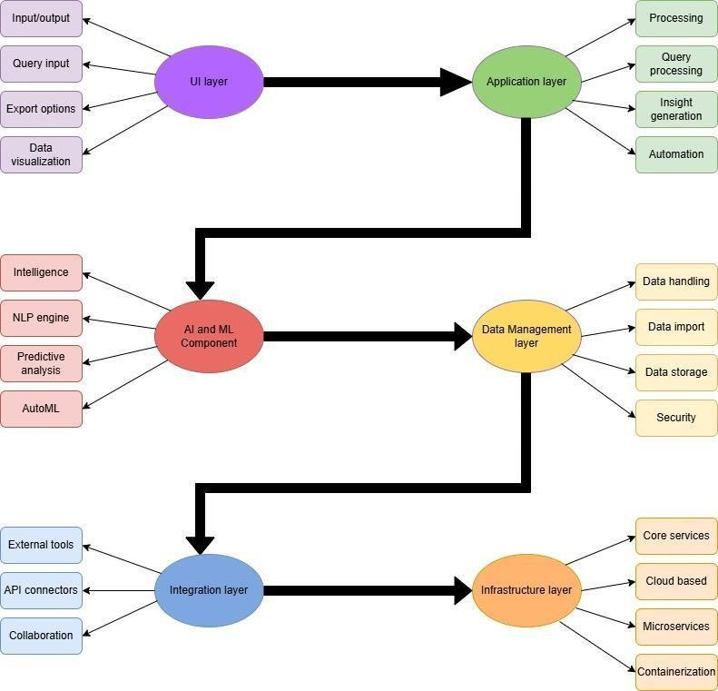

  - System Level Architecture
Dialogix is designed as a multi-layered system to efficiently handle user interactions, AI-powered processing, and secure data storage for business analytics functionality.

User Interface Layer Purpose:
Provides an intuitive and responsive interface for users to interact with DialogixAI.

Components:

- Dashboard Module: Presents data visualizations, reports, and insights.

- NLP Query Interface: Accepts natural language queries and returns AI-driven results.

Technologies Used:
- React (with TypeScript), Vite, TailwindCSS

- Chart.js for dynamic data visualizations

- dom-to-image-more for exporting visual dashboards

Key Features:
- Interactive and responsive design

- Real-time form validation

- Natural language query input

- Exportable dashboards

Application Logic Layer Purpose:
Acts as the brain of the system by integrating AI components and handling all logical operations.

Components:
- AI Engine:

  - Processes user queries using NLP

  - Detects intent and provides insights using ML models

Query Processor:

  - Validates and interprets queries

  - Converts natural language into structured SQL

  - Interacts with Supabase (PostgreSQL) for execution

Workflow Manager:

  - Orchestrates the query-to-visualization pipeline

Key Features:
- Scalable and modular logic

- Seamless AI + database integration

- Real-time insight generation using trained ML models

Data Storage Layer Purpose:
Stores user datasets, machine learning models, and system outputs securely and efficiently.

Components:
- Dataset Storage: For raw and processed CSV/Excel files

- Model Repository: To store trained AI/ML model files

- Analytics Database: Logs queries, usage stats, and AI-generated insights

Storage Types:
- Structured Database:
Supabase (PostgreSQL) – used for all tabular and relational data (e.g., users, datasets, queries, visual configs)

Object Storage:
Supabase Storage – used for uploaded files, exported reports, and saved ML models

Software Architecture

DialogixAI follows a three-tiered software architecture comprising the User Layer, Middle Tier (Logic & API Layer), and Database Layer. Each layer plays a critical role in managing user interaction, processing logic, and data storage.

User Layer Purpose:
Acts as the point of interaction for end-users, offering a visually engaging and intuitive interface for
querying, visualizing, and interpreting data insights.

Components:
  - Natural Language Query Module:
Accepts user queries in plain English (via text input; voice support can be added optionally).

Dashboard & Visualization Module:
Displays insights using dynamic charts, graphs, and tables. Allows customization of visual formats, filters, and views.

Interactive Elements:
Includes search bars, dropdowns, buttons, and responsive UI elements to enhance user experience.

Technologies:
  - Frontend Frameworks: React (with TypeScript), Vite, TailwindCSS

  - Visualization Tools: Chart.js (currently used), D3.js or ECharts (future integration options)

  - Export Tool: dom-to-image-more for exporting dashboard visuals

Middle Tier (Logic and API Layer) Purpose:
Processes user input, applies natural language understanding, manages business logic, and connects the frontend to backend services and storage.

Components:
  - API Gateway:
Handles API requests/responses between frontend and backend
Ensures user authentication and rate limiting (managed via Supabase Auth)

NLP & Model Processing Module:
Uses NLP/ML models to interpret user queries
Detects intent and maps queries to appropriate SQL and visual workflows

Business Logic Manager:
Executes data analytics logic, filtering rules, and transformation pipelines

Integration Manager:
Ensures smooth interaction between internal modules and third-party tools (e.g., AI libraries, external BI tools, or storage services)

Technologies:
  - Backend Frameworks: Node.js (future), Supabase Functions (current implementation)

  - NLP Libraries: Hugging Face Transformers (for fine-tuned intent detection), possibly SpaCy/NLTK

  - APIs: RESTful endpoints (Supabase), future GraphQL possible

  - Authentication: Supabase Auth with JWT-based user session management

Database Layer (Storage & Data Management) Purpose:
Stores and retrieves all user datasets, system-generated insights, and AI models securely and efficiently.

Components:
  - Structured Database (Relational):
Stores users, datasets, processed data, query history, and visual configs
Technology: PostgreSQL via Supabase

Object Storage:
Stores raw data files, uploaded CSVs, and ML model files
Technology: Supabase Storage (alternative to AWS S3 or GCS)

Model Repository:
Maintains versioned and trained ML/NLP models used for prediction and intent detection

Data Caching Layer:
Speeds up performance by caching frequently used visualizations or results
Technology (optional for future): Redis or Supabase edge functions with local cache

Design Strategy

The design strategy for Dialogix is focused on creating a scalable, user-centric, and AI-powered business analyst chatbot that simplifies data querying and visualization. This strategy will ensure seamless interaction, high performance, and modular extensibility for future enhancements.

User-Centric Interface Design Goal:
Create an intuitive and user-friendly interface that makes data analytics accessible to users of varying technical expertise.

Approach:
  - User Research:
Conduct surveys and user testing to understand pain points and preferences for interacting with analytical tools.

Natural Language Inputs:
Simplify complex data queries using conversational AI for non-technical users.

Visualization-Driven Design:
Present key insights visually using responsive dashboards.

Accessibility:
Adhere to accessibility standards (WCAG 2.1) to make Dialogix inclusive for users with disabilities.

Key Technologies:
  - React, TypeScript (frontend).
  - Visualization libraries like D3.js, Chart.js, or Highcharts.

Modular Architecture Design Goal:
Enable easy extension and maintenance by breaking the system into modular and reusable components.

Approach:
  - Component-Based Development:
Develop independent, reusable components for the UI (e.g., query input, result display, chart widgets).

Microservices Approach (Optional):
Use a microservices-based architecture for backend processing to allow independent scaling of features such as NLP, analytics, and data management.

APIs for Scalability:
Design RESTful or GraphQL APIs to decouple the frontend from backend services and support external integrations

Goal:
- AI-Driven Functionality

Deliver meaningful insights and improve the data querying experience using advanced AI and NLP capabilities.

Approach:
  - Natural Language Understanding (NLU):
Utilize NLP frameworks like Hugging Face Transformers or SpaCy to process user queries.

Intent Recognition and Context Handling:
Ensure the chatbot accurately understands queries by designing AI models tailored for business analytics.

Machine Learning Integration:
Leverage pre-trained and fine-tuned models for generating insights, detecting anomalies, and predicting trends.

Robust Data Management Strategy Goal:
Ensure high performance, data integrity, and scalability for handling structured and unstructured
datasets.

Approach:
  - Hybrid Storage Architecture:
    - Use structured databases (PostgreSQL) for transactional data and query logs.
    - Incorporate NoSQL databases for unstructured or semi-structured data.

Data Security:
Implement secure access control, data encryption, and regular backups.

Caching Mechanisms:
Use in-memory stores like Redis to improve the response time for frequently queried data.

Scalable and Performant Design Goal:

Support growing data volumes and increasing user demands without compromising performance.

Approach:
  - Scalability:
    - Deployment via Vercel (frontend) and Supabase (backend)
      - Use cloud services (AWS, Azure, or GCP) to provide scalable storage and compute power.

Optimization:
  - Optimize APIs for high-speed responses.
  - Use asynchronous processing for time-intensive tasks such as data queries and model predictions.

Development Process and Best Practices Goal:

Follow a structured development methodology to ensure high-quality output.

Approach:
  - Agile Development:
Use iterative development cycles for quick releases and improvements.

Continuous Integration/Continuous Deployment (CI/CD):
Implement CI/CD pipelines for automated testing and deployment.

Testing Strategy:
    - Perform unit, integration, and end-to-end tests to ensure robust functionality.
    - Test AI components for accuracy and bias mitigation.

Security and Design Goal:
Protect user data and application integrity from threats.

Approach:
  - Authentication and Authorization:
    - Supabase handles user authentication and session management.

Data Privacy:
  - Comply with data protection regulations (e.g., GDPR).
  - Encrypt sensitive user data both in transit and at rest.

Threat Mitigation:
  - Regularly audit the system for vulnerabilities.

Development Process and Best Practices Goal:
Follow a structured development methodology to ensure high-quality output.

Approach:
  - Agile Development:
Use iterative development cycles for quick releases and improvements.

Continuous Integration/Continuous Deployment (CI/CD):
Implement CI/CD pipelines for automated testing and deployment.

Testing Strategy:
    - Perform unit, integration, and end-to-end tests to ensure robust functionality.
    - Test AI components for accuracy and bias mitigation.

Prepare Dialogix for future requirements and emerging technologies.

Approach:

  - Feature Roadmap:
Plan features such as backend integrations, advanced analytics, and real-time streaming support.

Plug-and-Play Architecture:
Design modules (like AI engines or visualization tools) that can be replaced or updated without affecting the rest of the system.
By aligning with these strategies, Dialogix can deliver a cutting-edge solution for data analytics with scalability, usability, and AI-driven insights at its core.

Detailed System Design

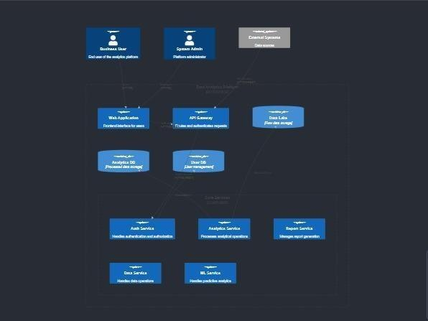 :

  - Design Class Diagram
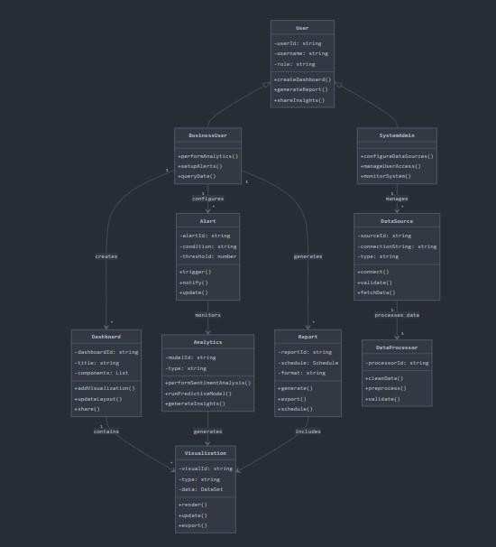

  - Database Design

    - ER Diagram
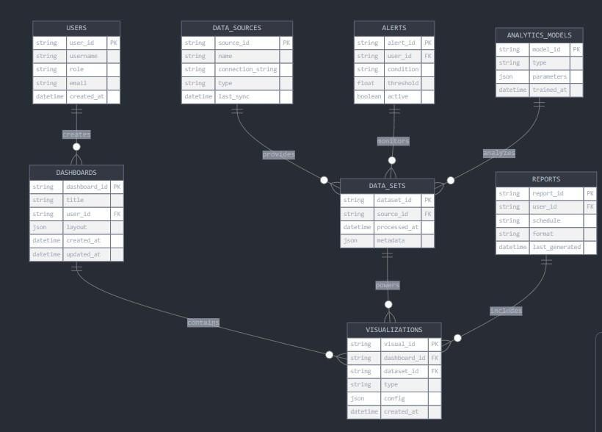

    - Data Dictionary Users table

Column Name | Description | Type | Constraints
user_id | Unique user identifier | STRING | PK
username | Username of the user | STRING | NOT NULL, UNIQUE
role | Role of the user | STRING | NOT NULL
email | Email address of user | STRING | NOT NULL, UNIQUE
created_at | Timestamp of account creation | DATETIME | NOT NULL

Data_sources table

Column Name | Description | Type | Constraint
source_id | Unique data source identifier | STRING | PK
name | Name of the data source | STRING | NOT NULL
connection_string | Connection configuration for source | STRING | NOT NULL
type | Type of data source (e.g., DB, file) | STRING | NOT NULL
last_sync | Last synchronization timestamp | DATETIME

Dashboards table
Column Name | Description | Type | Constraints
dashboard_id | Unique identifier for dashboard | STRING | PK
title | Title of the dashboard | STRING | NOT NULL
user_id | Reference to USERS table | STRING | FK
layout | Layout configuration (JSON) | JSON | NOT NULL
created_at | Timestamp of dashboard creation | DATETIME | NOT NULL
updated_at | Timestamp of the last update | DATETIME

Alerts table
Column Name | Description | Type | Constraints
alert_id | Unique identifier for alert | STRING | PK
user_id | Reference to USERS table | STRING | FK
condition | Trigger condition for alert | STRING | NOT NULL
threshold | Threshold for the alert | FLOAT | NOT NULL
active | Active status of the alert | BOOLEAN | NOT NULL

Visualizations table

Column Name | Description | Type | Constraints
visual_id | Unique visualization identifier | STRING | PK
dashboard_id | Reference to  DASHBOARDS table | STRING | FK
dataset_id | Reference to  DATA_SETS table | STRING | FK
type | Type of visualization (e.g., bar, line) | STRING | NOT NULL
config | Visualization configuration (JSON) | JSON | NOT NULL
created_at | Timestamp of  visualization creation | DATETIME | NOT NULL

Data_sets table

Column Name | Description | Type | Constraints
dataset_id | Unique identifier for dataset | STRING | PK
source_id | Reference to DATA_SOURCES  table | STRING | FK
processed_at | Timestamp of data processing | DATETIME | NOT NULL
metadata | Metadata details (JSON) | JSON | NOT NULL

Analytics_models table

Column Name | Description | Type | Constraints
model_id | Unique identifier for the model | STRING | PK
type | Type of model (e.g., ML, DL) | STRING | NOT NULL
parameters | Parameters of the model (JSON) | JSON
trained_at | Timestamp of training | DATETIME | NOT NULL

Reports table

Column Name | Description | Type | Constraints
report_id | Unique identifier for the report | STRING | PK
user_id | Reference to USERS table | STRING | FK
schedule | Report generation schedule | STRING
format | Format of the report (e.g., PDF) | STRING | NOT NULL
last_generated | Timestamp of the last generation | DATETIME

  - Application Design

    - Sequence Diagram 1
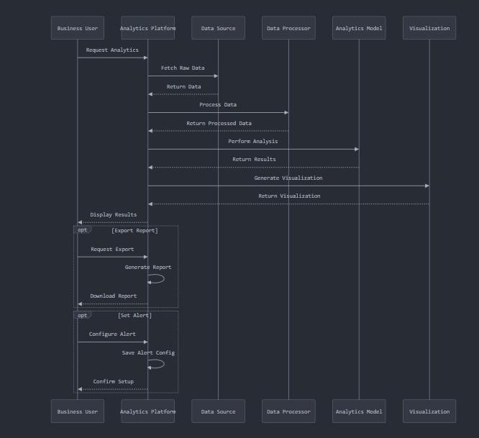

      - Sequence Diagram 2
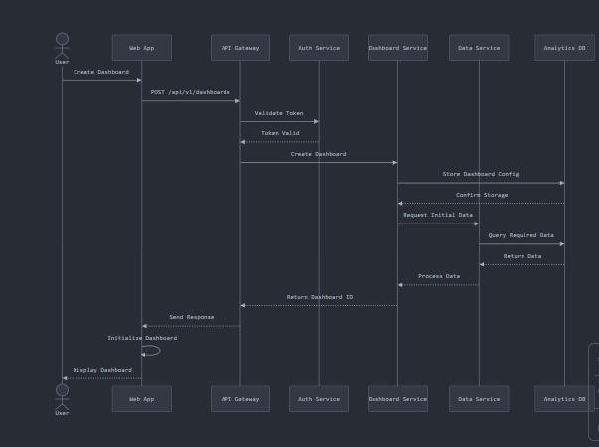

This sequence diagram outlines the process of creating and initializing a dashboard:

Actors and Components
        - User: Initiates dashboard creation.
        - Web App: Interface for user interaction.
        - API Gateway: Handles API requests.
        - Auth Service: Validates user token.
        - Dashboard Service: Manages dashboard creation.
        - Data Service: Retrieves and stores data.
        - Analytics DB: Stores required data.

Process Steps

- Create Dashboard:

  - User initiates dashboard creation via the Web App, which sends a POST request to the API Gateway.

Token Validation:

  - API Gateway forwards the request to the Auth Service to validate the user's token.

Dashboard Creation:

  - Once validated, the API Gateway requests the Dashboard Service to create the dashboard.

Data Handling:

  - Dashboard Service stores the configuration via Data Service, which fetches required data from Analytics DB.

Response:

  - Dashboard ID is returned to the Web App, which initializes and displays the dashboard to the user.

Highlights
- Authorization: Ensures only valid users access the system.
- Data Flow: Clear interaction among modular components.
- Efficiency: System retrieves, processes, and stores data seamlessly.

.

Sequence Diagram 3
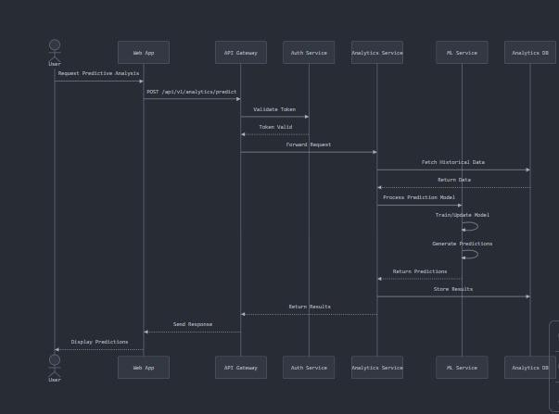

This sequence diagram outlines the process of predictive analysis in a system:

Actors and Components
        - User: Requests predictive analysis via the Web App.
        - Web App: User interface for interactions.
        - API Gateway: Handles requests.
        - Auth Service: Validates user authorization.
        - Analytics Service: Manages the analysis process.
        - ML Service: Trains and generates predictions.
        - Analytics DB: Stores historical data and results.

Process Steps

- Request: User requests analysis via Web App, which sends a POST request to the API Gateway.
- Validation: API Gateway validates the user’s token via the Auth Service.
- Data Fetch: Analytics Service retrieves historical data from the Analytics DB.
- Prediction: ML Service trains the model and generates predictions.
- Results: Predictions are stored in the Analytics DB and sent to the Web App for display to the user.

Key Highlights
  - Authorization: Ensures secure access.
  - ML Integration: Efficient model training and prediction.
  - Result Storage: Enables future reference.

State Diagram
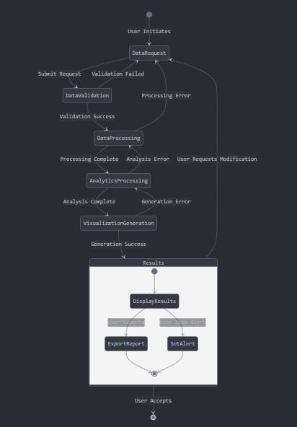

This flowchart illustrates the data request and processing workflow within a system:

- User Initiates: The process starts with the user submitting a DataRequest.

Validation:
  - If the request passes validation (Validation Success), the system moves to

DataProcessing.
  - If validation fails, an error is reported (Validation Failed).

Processing:
  - After successful data validation, the system processes the data.
  - If an error occurs during processing (Processing Error), it halts.
  - If processing completes, the system transitions to AnalyticsProcessing.

Analytics:
  - Analytics are performed on the data.
  - Errors in analysis (Analysis Error) prompt user modifications or halt the process.
  - Once analysis is complete, the system generates visualizations (VisualizationGeneration).

Visualization:
  - Visualization generation can succeed or fail (Generation Error).
  - Successful visualizations lead to the Results phase.

Results:
  - The results are displayed (DisplayResults).
  - Users can:

Export Reports.
    - Set Alerts.
  - Users can accept the results, concluding the process.

This diagram outlines a structured process for handling, analyzing, and visualizing data, with error handling at every step.

GUI Design
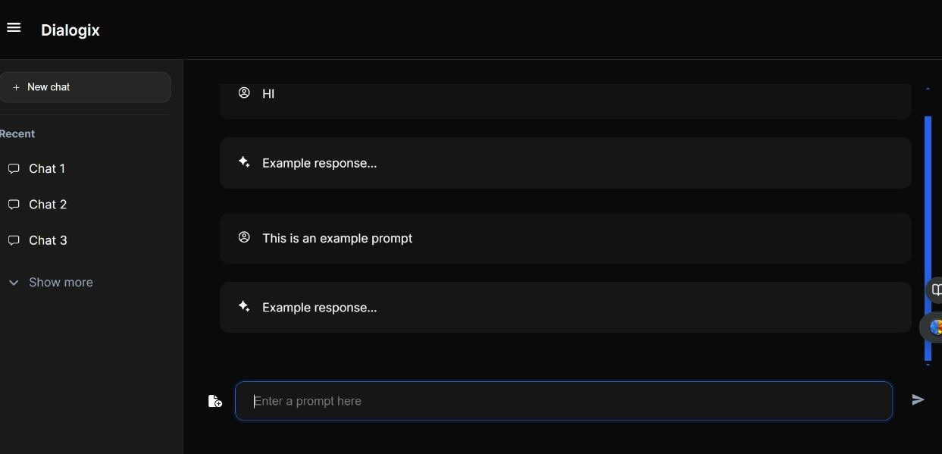

- Create Interactive Dashboards Description:
This screen would show a customizable dashboard where business users can add widgets, charts, and data visualizations to analyze real-time data. Options to drag, resize, and filter the data are available.

Key Features:
- Widget Library (charts, graphs, etc.)
- Filters and drill-down capabilities
- Save and load dashboards
- Share dashboard functionality

Import Data and Clean & Preprocess Data Description:
This screen would allow users to upload datasets from local files or connect to external systems. The user can preview the data and perform preprocessing tasks such as handling missing

values or transforming data.

Key Features:
- File upload/connection setup
- Data preview with rows/columns
- Data cleaning options (e.g., fill missing data, normalize)
- Status indicators for data readiness

Perform Predictive Analytics Description:
A detailed screen that provides a predictive modeling environment where users can select models, set parameters, and run analysis. Results are shown visually with performance metrics.

Key Features:
- Model selection (regression, classification, etc.)
- Input configuration for models
- Run button with real-time analytics progress
- Results and visualizations (e.g., predictions, accuracy scores)

References

- Dialogix Proposal Document
- FYP Presentation Slides
- Agile Methodology Resources

A4. OTHER TECHNICAL DETAIL DOCUMENTS

Test Cases Document

Test Case ID | Feature | Test Scenario | Test Step s | Expected Result | Actual Result | Statu s | Remar ks
TC-0 01 | User Login | User logs in with valid credentials | 1-2-3 | Dashboard is displayed | As  expecte d | Pass
TC-0 02 | Natural  Language Query Input | User submits a valid query  (e.g., “Show  sales by  region”) | 1-2-3 | Relevant  chart/data is displayed | As  expecte d | Pass
TC-0 03 | Query with no result | User submits a vague or incomplete query | 1-2-3 | Error message: “No data found.” | As  expecte d | Pass
TC-0 04 | Visualization Customizatio n | User changes chart type | 1-2-3 | Selected chart updates accordingly | As  expecte d | Pass
TC-0 05 | Export Dashboard | User clicks “Export to PNG” | 1-2-3 | Image is downloaded | As  expecte d | Pass

UI/UX Detail Document

Design Philosophy:
  - Clean, intuitive, and responsive interface

  - Dark and light mode support

  - Minimal clicks to insights

Screens & Navigation:
  - Login Page: Email, password input, remember me checkbox

  - Dashboard: Cards for quick stats, chart area, side navigation

  - Query Interface: Text input + voice input, submit button

  - Visualization Panel: Chart.js components, export/download options

  - User Profile: Settings, logout

Tools Used:
  - Figma (Wireframes, Mockups)

  - TailwindCSS for consistent styling

  - React for interactive UI

Coding Standards Document Languages & Frameworks:
  - TypeScript + React (Frontend)

  - Supabase (Backend)

  - Tailwind CSS (Styling)

File/Folder Structure:

css CopyEdit src/
├── components/
├── pages/
├── services/
├── utils/

Naming Conventions:
  - Components: PascalCase (e.g., QueryPanel.tsx)

  - Variables: camelCase

  - Constants: UPPER_SNAKE_CASE

Commenting:
  - Single-line for logic explanation

  - JSDoc-style for functions

Version Control:
  - GitHub: main, dev, and feature/* branches

  - Pull requests reviewed before merging

Security Practices:
  - Never expose API keys

  - Sanitize user input

  - Authentication via Supabase

Project Policy Document

Team Members & Roles:
  - Sonu Kotak: Team Lead, Dataset Management

  - Mahwish Fatima: Frontend Design & Integration

  - Tayyaba Faisal: NLP Integration & Testing

Meetings & Communication:
  - Weekly progress meetings (Google Meet)

  - WhatsApp group for daily coordination

  - Google Docs for collaborative documentation

Decision-Making:
  - Team discussion + supervisor approval

  - Prioritized user-friendly and scalable features

Scope Control:
  - Added features only if they passed a feasibility + impact check

  - Adjusted NLP scope after mid-evaluation feedback

Risk Management:
  - Git version control ensured code backup

  - Divided tasks to reduce bottlenecks

  - Slack time for integration and bug fixes

User Manual Document

Introduction:
DialogixAI is a web-based tool allowing users to query data using natural language and visualize results through interactive dashboards.

System Requirements:
  - Modern browser (Chrome/Edge/Firefox)

  - Stable internet connection

  - Desktop or laptop preferred

Getting Started:

- Open website (URL)

- Register or Login

- Enter your query in plain English

- View the results on the dashboard

- Customize the chart (Bar, Pie, Line)

- Click Export to download the dashboard

Example Queries:
  - “Show me sales from January to March”

  - “Total revenue by region”

  - “Compare product A and B performance”

Troubleshooting:
  - No results? Try rephrasing your query

A5. FLYER & POSTER DESIGN

A6. COPY OF EVALUATION COMMENTS COPY OF EVALUATION COMMENTS BY
SUPERVISOR FOR PROJECT – I MID SEMESTER
EVALUATION

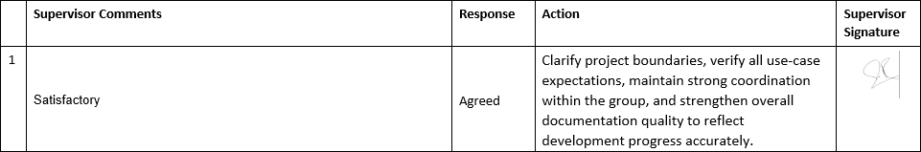

COPY OF EVALUATION COMMENTS BY
SUPERVISOR FOR PROJECT – I END SEMESTER EVALUATION
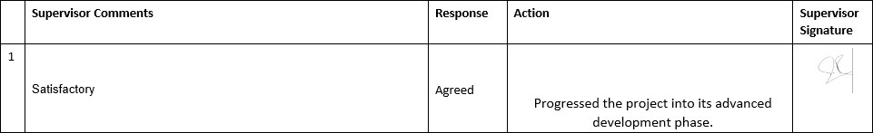

COPY OF EVALUATION COMMENTS BY JURY FOR PROJECT – I END SEMESTER EVALUATION
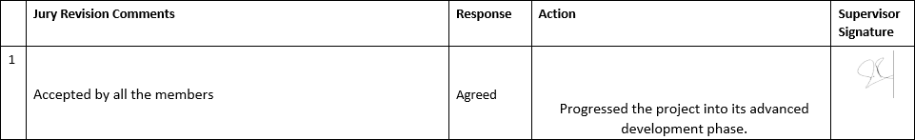

COPY OF EVALUATION COMMENTS BY
SUPERVISOR FOR PROJECT – II MID SEMESTER EVALUATION

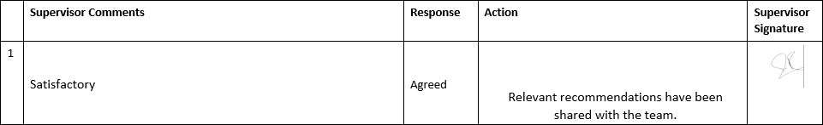

List of Participants
Name | Project Role
Sonu Kotak | Team Lead
Tayyaba Faisal | Research and Implementation
Mahwish Fatima Jafri | Research and Implementation

- Meeting Agenda

  - Discussing the scope of the project with Ma'am.
  - Initiating the project steps and resources required.
  - Training the model tools, techniques, and timeline.
  - Working on documentation structure, process, and key points to include.

Agenda Points discussed in meeting

During the meeting with my supervisor, we discussed several critical aspects of the project to ensure a clear path forward. First, we focused on defining the project’s scope, clarifying its objectives, boundaries, and expected outcomes. This was crucial for setting realistic goals and aligning expectations. Next, we explored the steps required to initiate the project, including identifying the necessary resources and tools, as well as creating a structured plan to guide the initial phases. The conversation then shifted to training the model, where we deliberated on the tools and techniques to use, along with establishing a timeline to ensure efficient development and testing. Lastly, we reviewed the approach to documentation, emphasizing its structure, the process for creating it, and the key points to include, such as milestones, technical details, and outcomes, to maintain a comprehensive and professional record of the project.

FYP Title: Dialogix | Version: <2.0>
Vision: To provide businesses with an intuitive, AI-powered data analytics platform that simplifies data tasks and supports informed decision-making through seamless integration and actionable insights. | Date: 06/10/2025
P34F24

Action List

TASKS | ASSIGNED TO | DEADLINE
Finalize the project scope document and get approval from Ma'am | All members | 20-12-2024
Prepare a detailed plan for initiating the project, including resources and timelines. | All members | 26-12-2024

Research and select the tools and techniques required for model training | All members | 01-01-2025
Create models and components for the project | All members | 02-01-2025
Prepare UML and  architecture diagrams | All members | 05-01-2025
Develop a timeline and allocate tasks for the model training process. | All members | 10-01-2025

Supervisor/Co-Supervisor Signature

A8. DOCUMENT CHANGE RECORD

Date | Version | Author | Change Details

A9. PROJECT PROGRESS
Photostat of Incremental versions of Requirement Signoff sheet submitted to Project Coordinator. (Note: Please remove this line when attach copy that is required)

A10. RESEARCH PAPER

